Several decades of sprites ?

It’s not a speed-run, it’s speed-coding

Krzysiek D.
What is SPRITE?

- Small 2D object

- It can be moved, scaled, and animated independently of the background or other objects

- Sprites are supported by specialized hardware features in many graphics systems, which allow for efficient rendering and manipulation

First video game (not computer game)
TENNIS FOR TWO (1958)
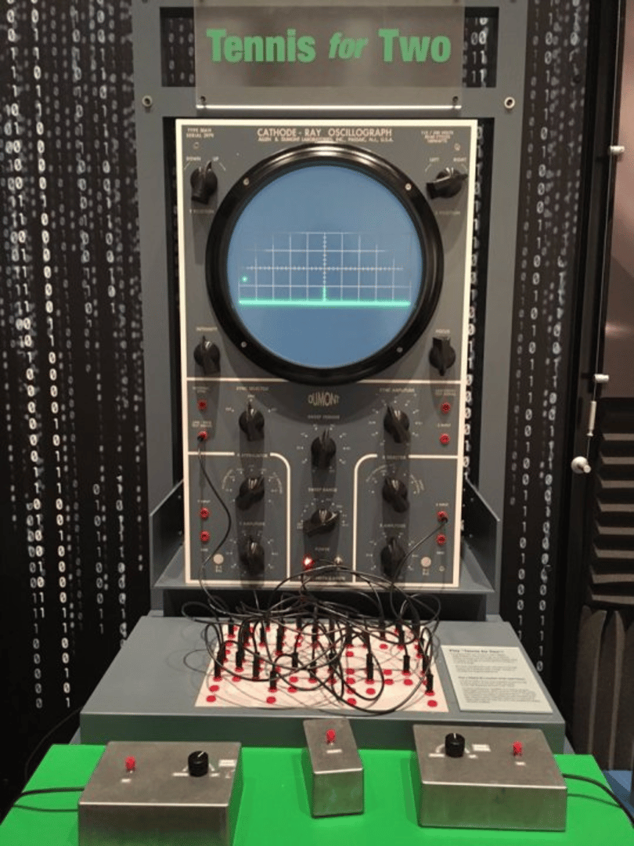
Second video game: Spacewar! (MIT 1962)
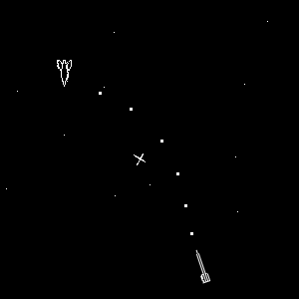

Pong (Atari 1972) – first commercial game
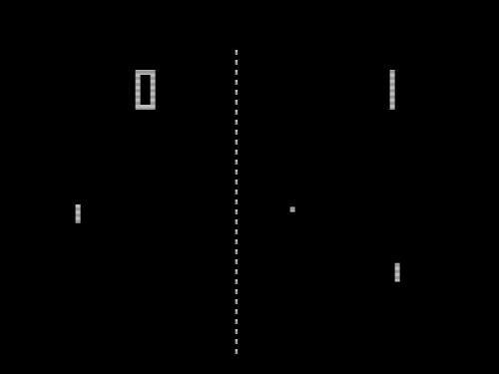

Atari 800XL (1981)
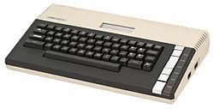

Commodore 64 (1982)

